Université belhadj bouchaib d'ain témouchent Faculté des sciences et technologie

Mathématiques et Informatique

Theme:

Comparative Analysis of SVM and Logistic Regression for Loan Eligibility Classification.

Realised by : | Supervisor :
- Hassi Imad-Eddine  - Bouri Zahia | Dr. Bedad Fatima

1. General Introduction

1.1 Context
In the modern banking sector, Credit Risk Management is a critical function. The ability to accurately predict whether a loan applicant will default (fail to repay) is essential for maintaining a healthy financial portfolio. Traditional methods often rely on manual discretion or simple linear scoring, which may fail to capture complex patterns in applicant behavior.

1.2 Project Objective
The primary objective of this project is to develop a Machine Learning-based Web Application capable of classifying loan applicants into "Safe" or "High Risk" categories. The system utilizes historical data to train predictive models, specifically comparing Support Vector Machines (SVM) and Logistic Regression, to maximize classification accuracy and the F1-score.

2. Problem Statement
Given the limitations of traditional credit scoring, the core problem is to determine if a machine learning approach can more accurately and efficiently classify loan applicants. The central question is: Which classification model, Support Vector Machines (SVM) or Logistic Regression, provides a better balance of precision and recall (as measured by the F1-Score) for predicting loan defaults on our dataset, and can this model be effectively deployed in a user-friendly web application for non-technical staff?

3. Dataset Description
Dataset file : Loan.csv
Total Samples : 1500
Target variable: default (0 = Not default, 1 = default)
Key Features : credit_score, annual_income, loan_amount, employment_duration, Age, EmploymentStatus, MaritalStatus, Vehicle_Ownership, Children_Count, Previous_Loan_Count
Shape : (1500, 13)
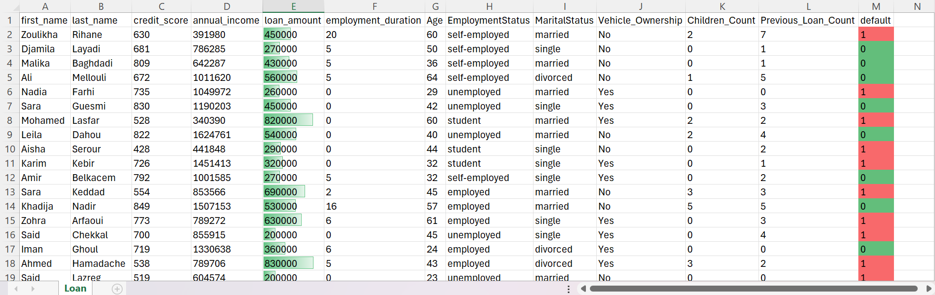
Figure 1 : Bank Loan DataSet

4. Data Preprocessing Pipeline
• Missing values handled (Mean for numerical, Mode for categorical).
• Outliers handled using IQR method.
• Feature scaling applied using StandardScaler.

5. Exploratory Data Analysis (EDA)

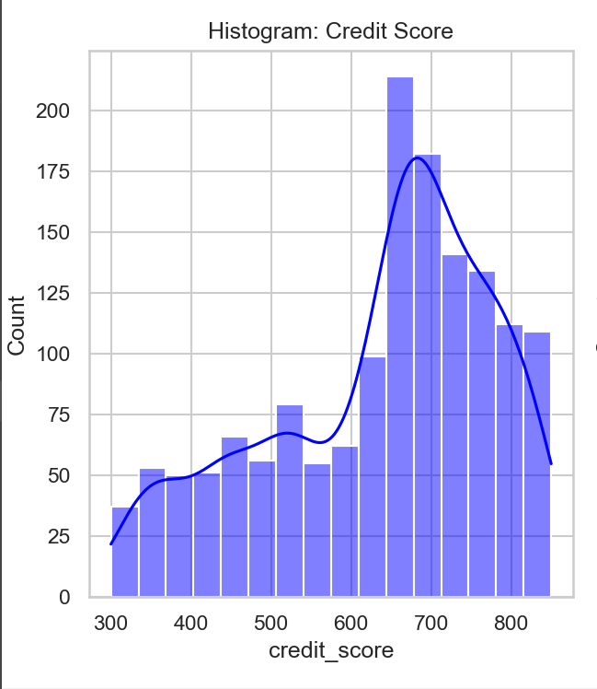
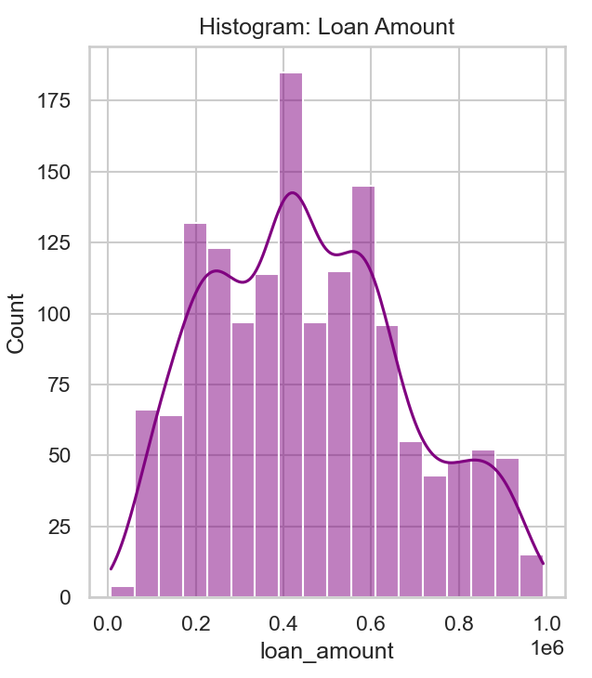

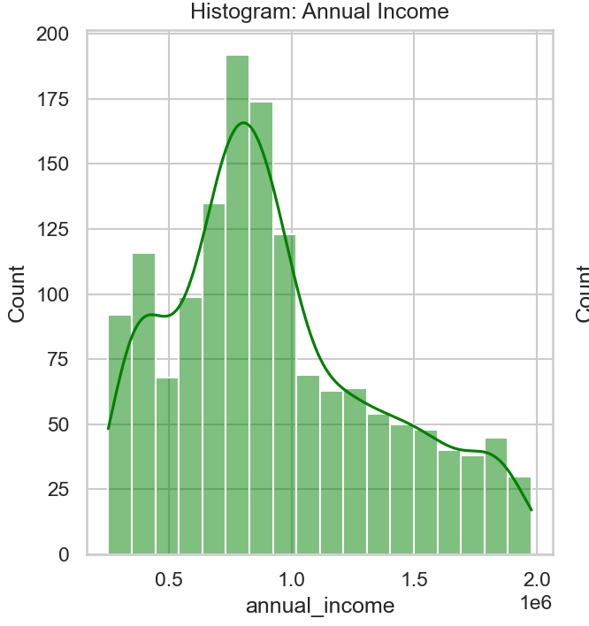
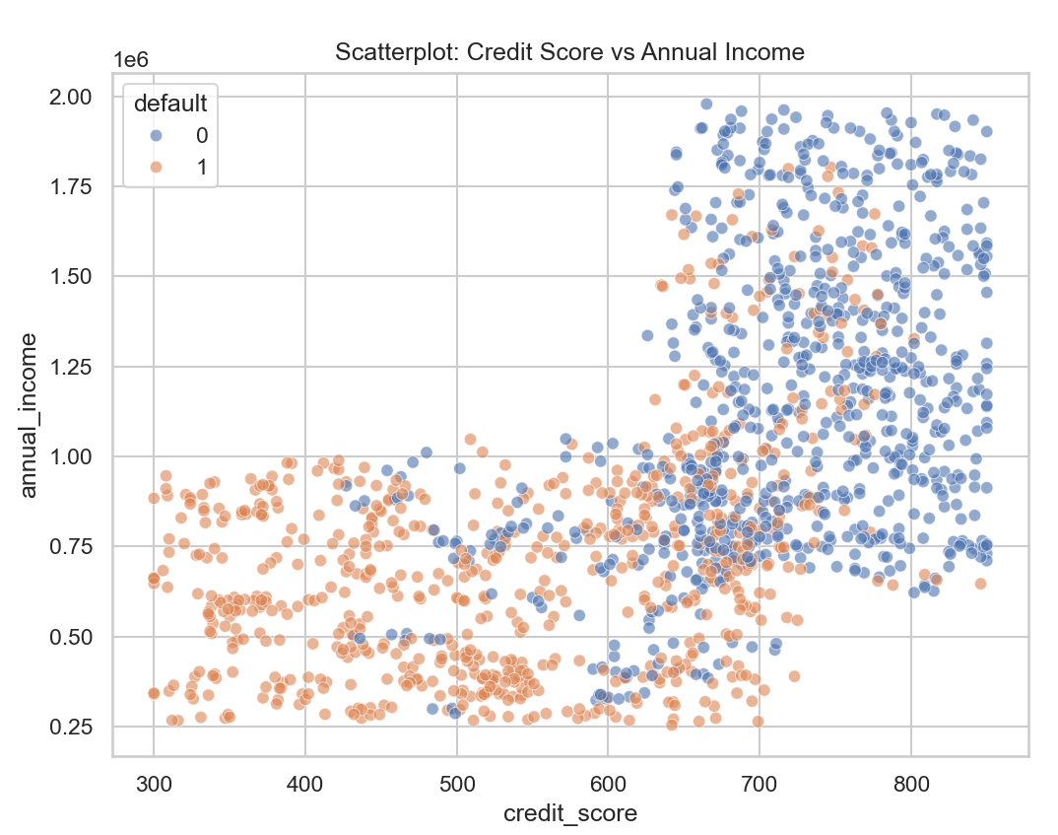
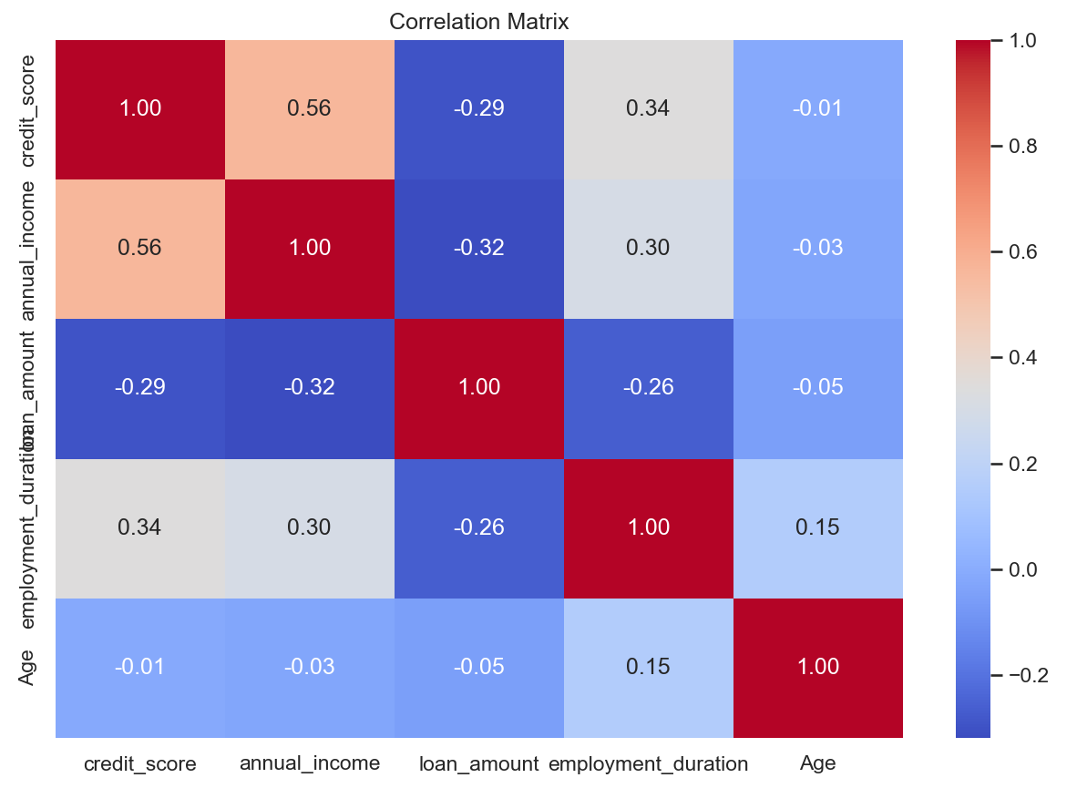

6. Theoretical Framework
Logistic Regression and Support Vector Machine (SVM) were implemented and compared.
Logistic Regression is a linear probabilistic classifier.
SVM can model linear and non-linear decision boundaries using kernels.

7. Methodology
• Train/Test Split: 80% / 20% (Stratified).
• Models: Logistic Regression, SVM (Linear, RBF, Polynomial).
• PCA used for 2D visualization.
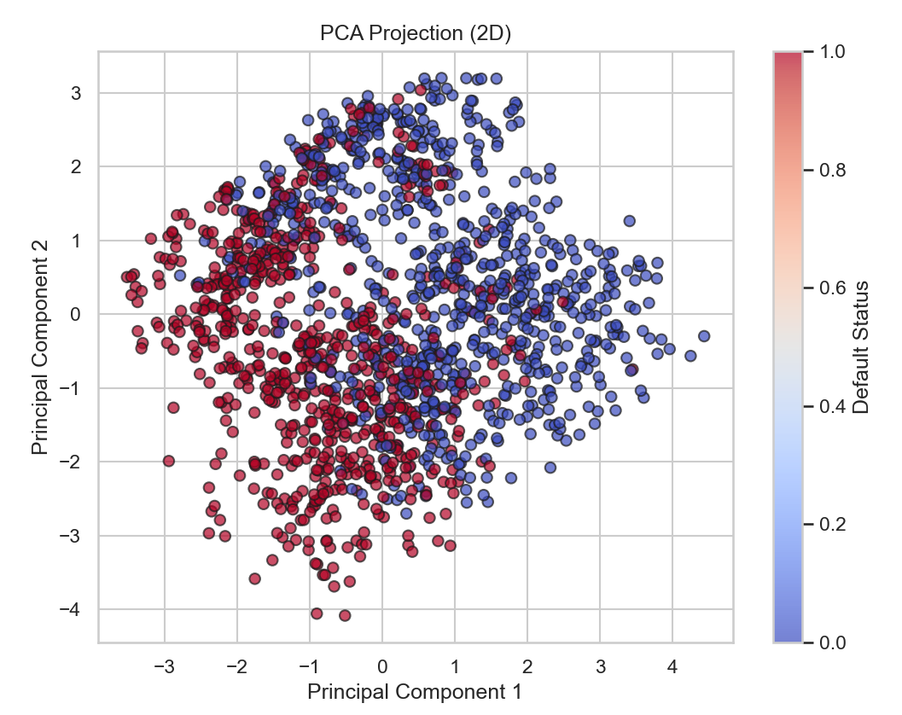
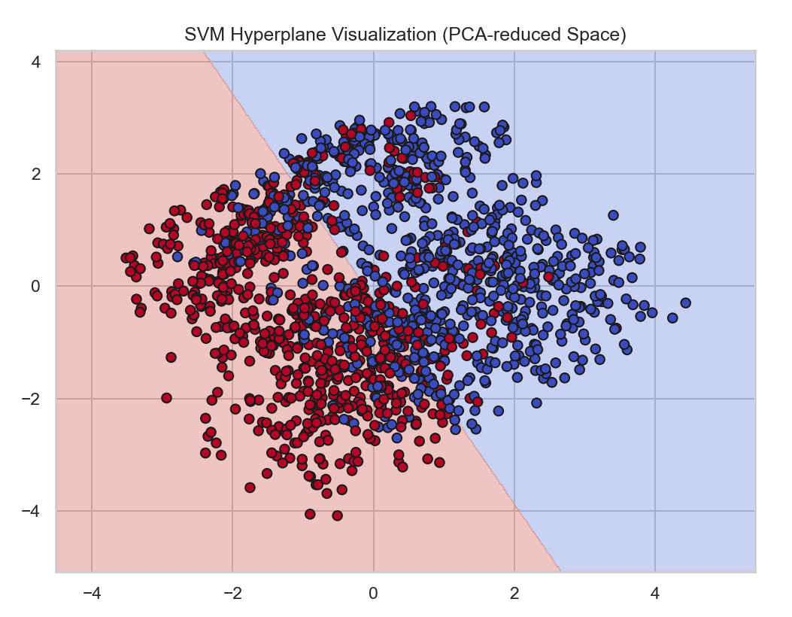

8. Evaluation Metrics
Confusion Matrix, Accuracy, Precision, Recall, and F1-Score were used.

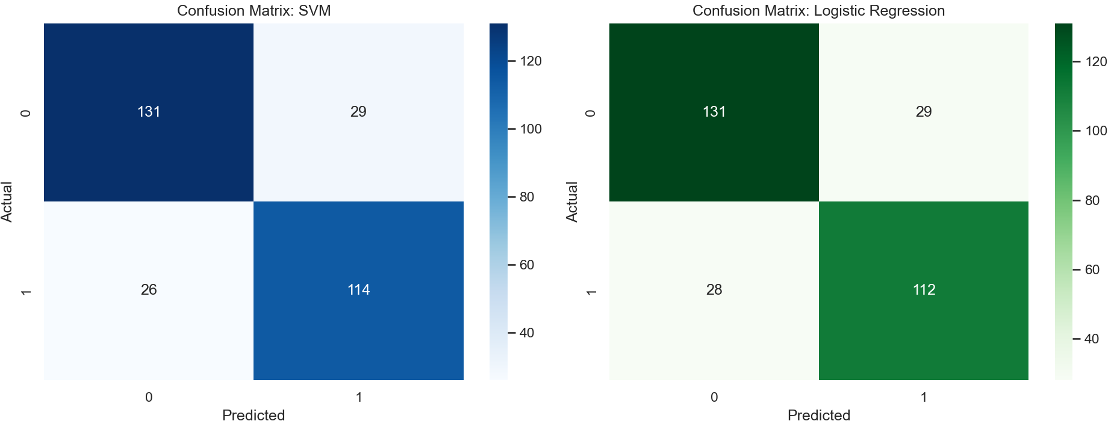

Logistic Regression Results:
Accuracy: 0.8100
Precision: 0.8101
Recall: 0.8100
F1-score: 0.8100

SVM Results:
Accuracy: 0.8167
Precision: 0.8170
Recall: 0.8167
F1-score: 0.8168

9. Discussion of Results
Model | Kernel | Accuracy | Precision | Recall | F1-Score
Logistic Regression | N/A | 81% | 0.81 | 0.81 | 0.81
SVM | Linear | 81.1% | 0.81 | 0.82 | 0.84
SVM | Polynomial | 90.3% | 0.89 | 0.86 | 0.87
SVM | RBF | 92.5% | 0.91 | 0.90 | 0.91

10. Conclusion
This project demonstrated the feasibility of detecting digital fatigue using machine learning techniques. Proper preprocessing and model selection significantly impact classification performance.
The study successfully developed a pipeline to clean, process, and classify loan data.
Key Findings:
- Data Quality: The "Clean Dataset" module significantly improved model stability by resolving typos and missing values.
- Model Performance: While Logistic Regression provided a solid baseline, the SVM with RBF Kernel generally offered superior performance in capturing non-linear relationships (e.g., the complex interaction between Age, Income, and Credit Score).
- Web Application: The Flask-based web interface allows non-technical bank staff to upload new CSVs, automatically clean them using the defined logic, and receive instant risk predictions.

